**Agenda for Day 4**:-

1. Module Initiation.
2. External library.
3. Datatable
4. Form elements
5. Modal window

**Module Initiation**:-

Step 1:-

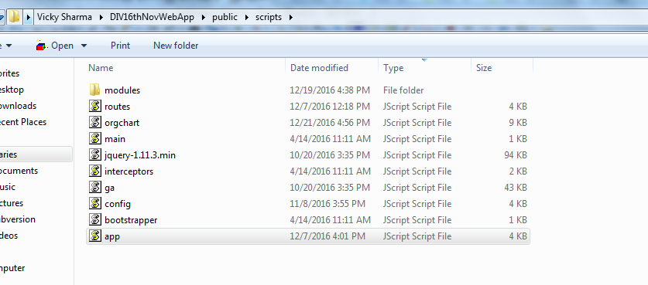

1. Add a new module:- define the module name as mentioned below:-

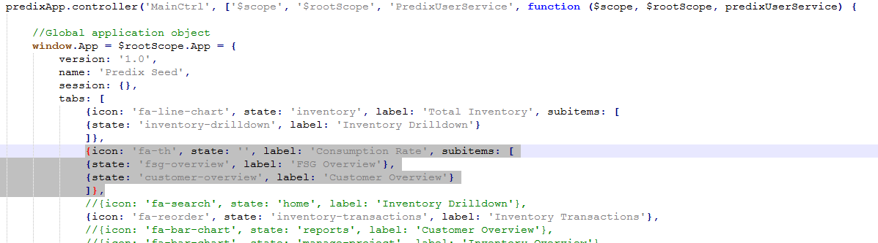

{icon: 'fa-th', state: '', label: 'Consumption Rate', subitems: [

{state: 'fsg-overview', label: 'FSG Overview'},

{state: 'customer-overview', label: 'Customer Overview'}

]}

Step 2:- define the state in routes.js as shown below:-

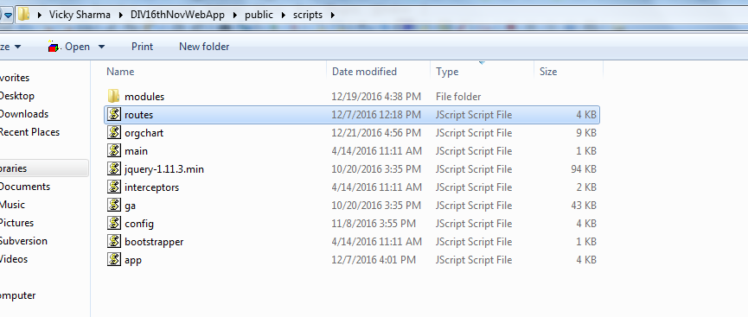

In routes.js:-

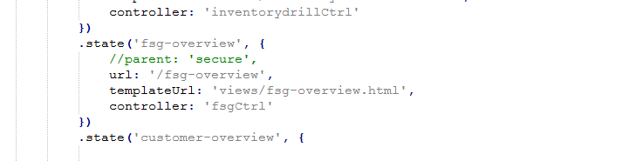

Note:- parent:’secure’ :-it is used to authenticate the file with sso.

Step:- create a controller eg:- fsg-overview-controller.js in below path:-

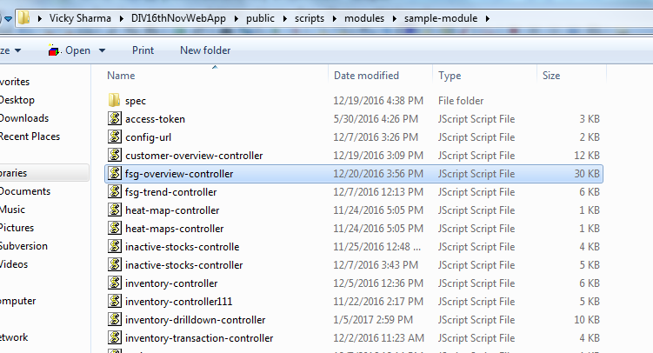

Make the entry of newly created eg:- fsg-overview-controller in main.js file. As below

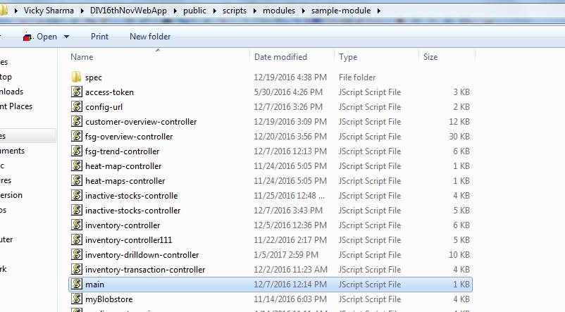

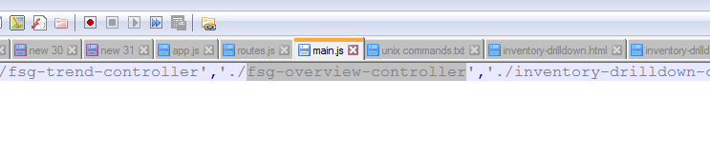

Inside the controller give a name to the controller eg:- fsgCtrl

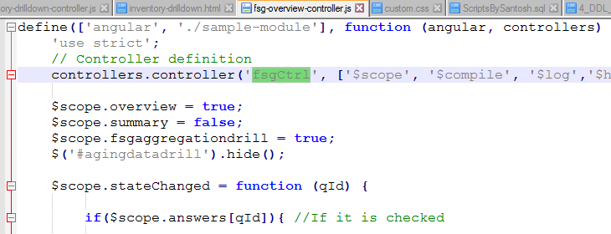

Now make an entry of controller name in routes.js file as mentioned below:-

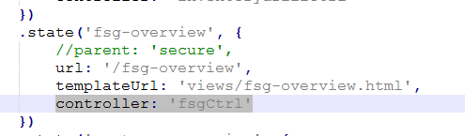

Now create the corresponding HTML file for the controller in below path:-

Eg:- C:\Users\vs825995\DIV16thNovWebApp\public\views

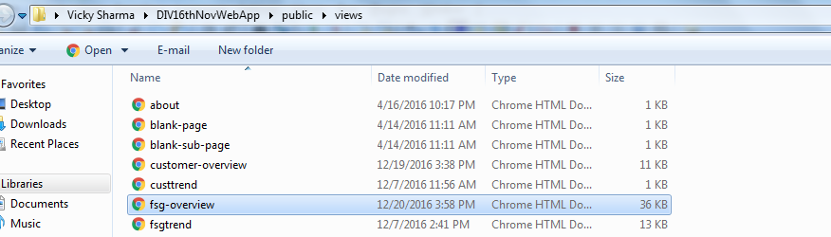

**Adding Custom CSS:-**

Create a stylesheet folder in below path:-

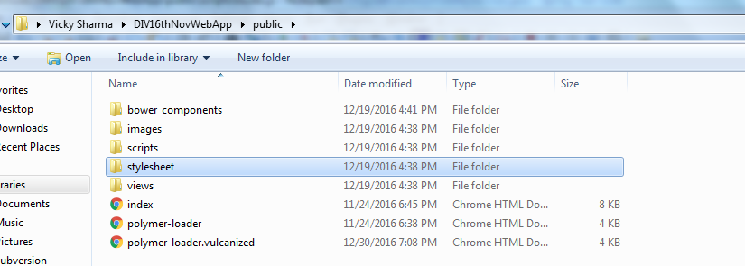

Create a custom .css file in it.

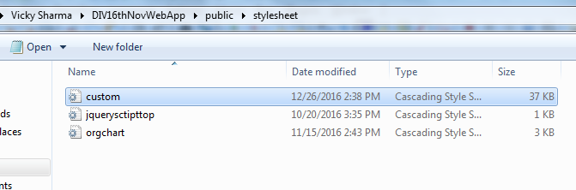

Make the entry of this custom.css file in polymer-loader.vulcanized.html file

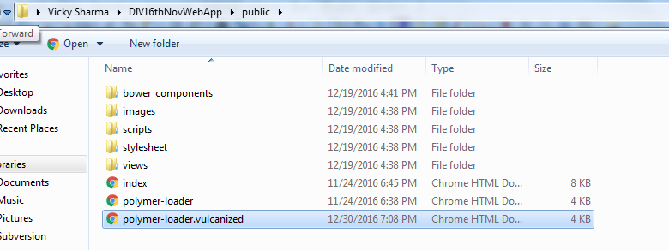

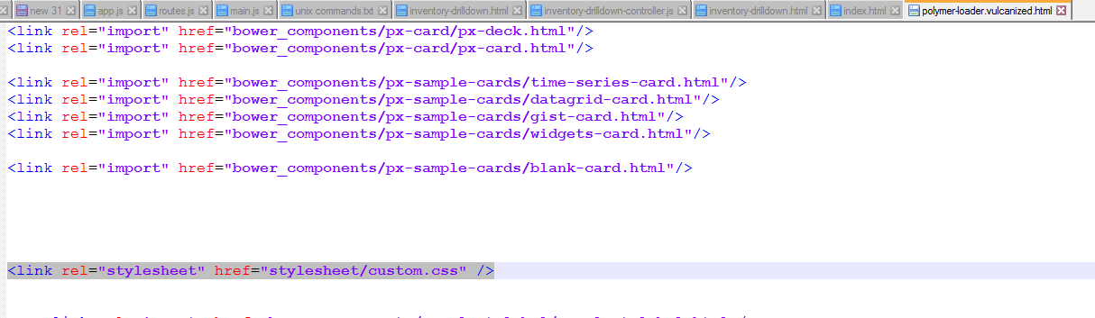

Note : - Best practice is to include the .CSS file once all the bower components are loaded. Since bower components also contains some inbuilt CSS which may override the custom .CSS.